LAB 1: Public AV Scanner and Sandbox
Course Name: Malware Analysis and Reverse Engineering (IAM302)
Student Name: Nguyễn Trần Vinh – SE160258
Instructor Name: Mai Hoàng Đỉnh
Lab Due Date: 4/2/2023

Purpose
Setup Sandbox, install SIFT Workstation, use tools to scan malware

Install SIFT
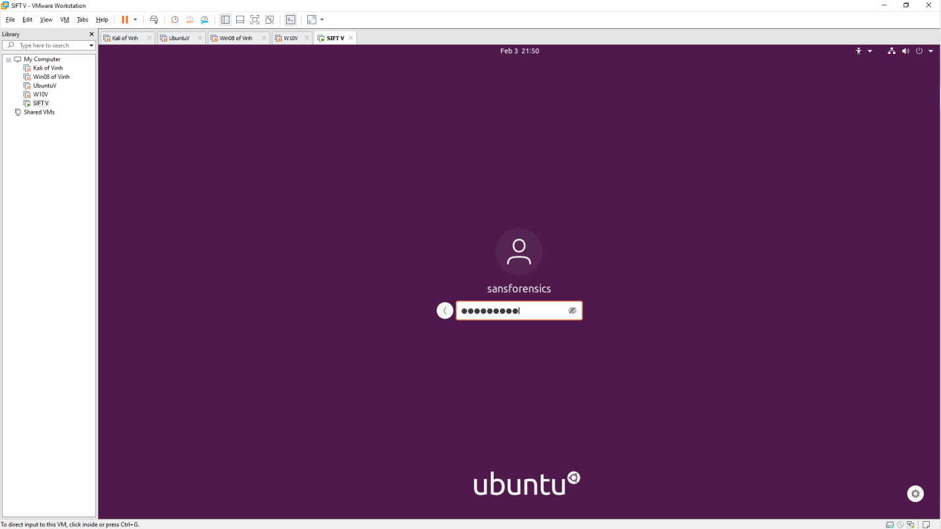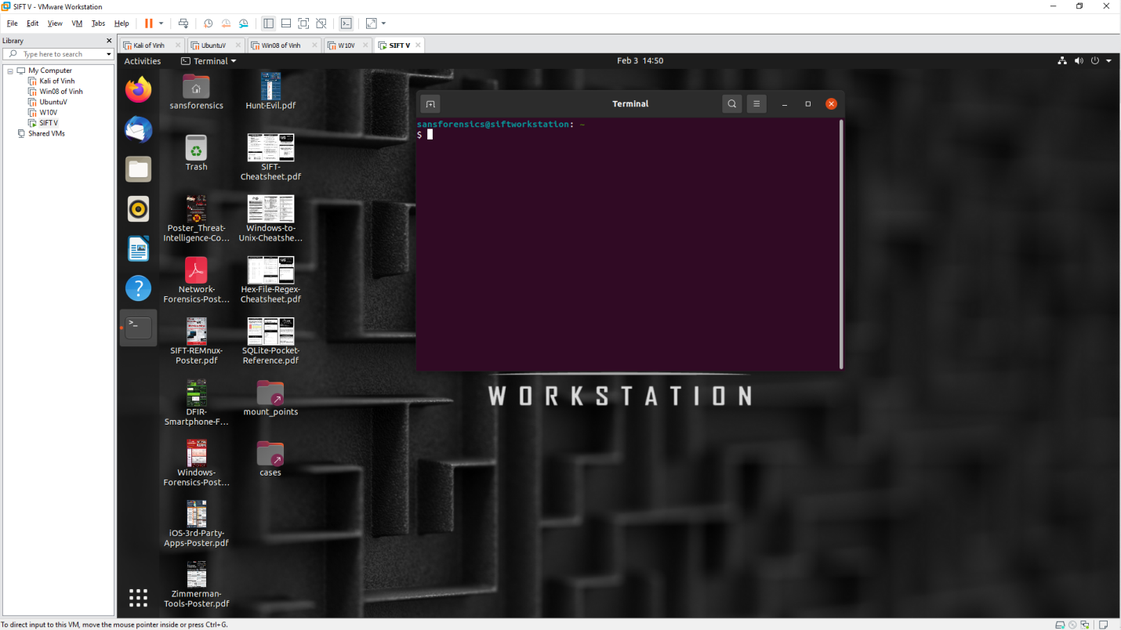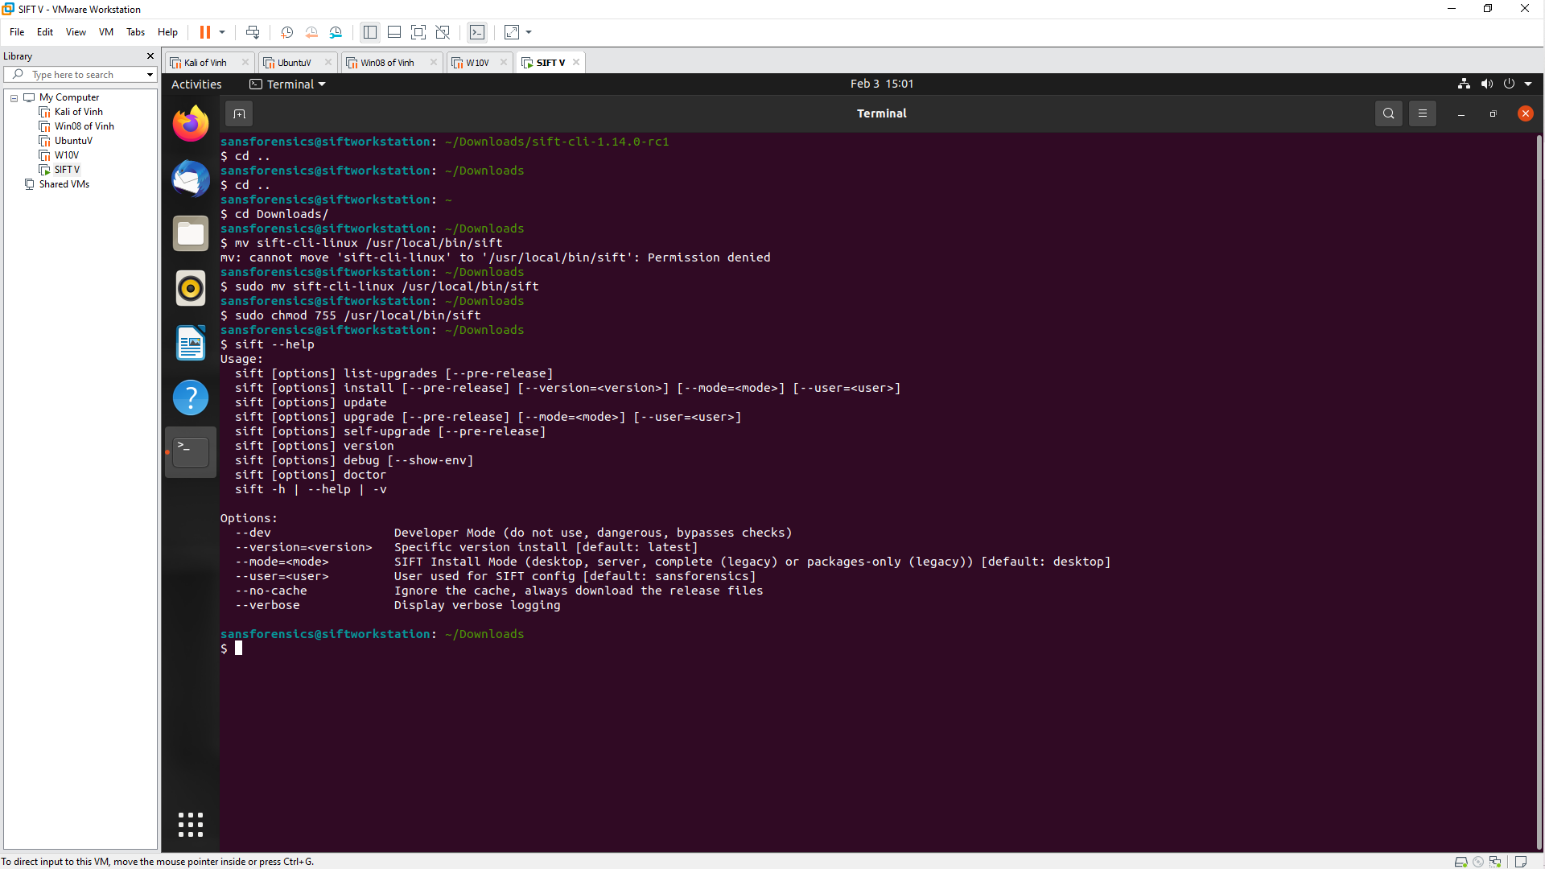

Download a sample malware
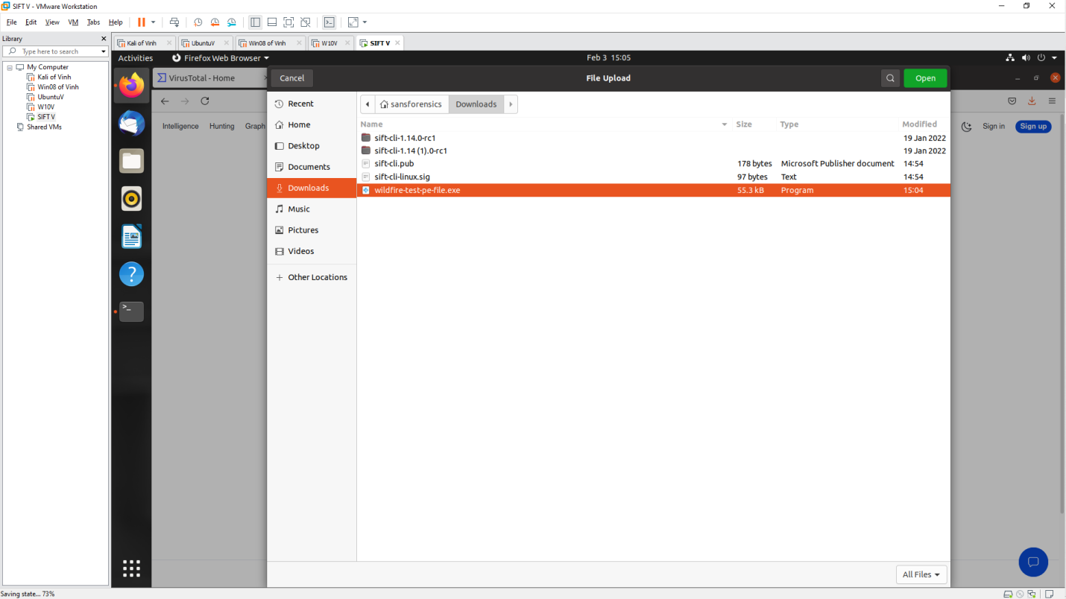

Upload to virustotal
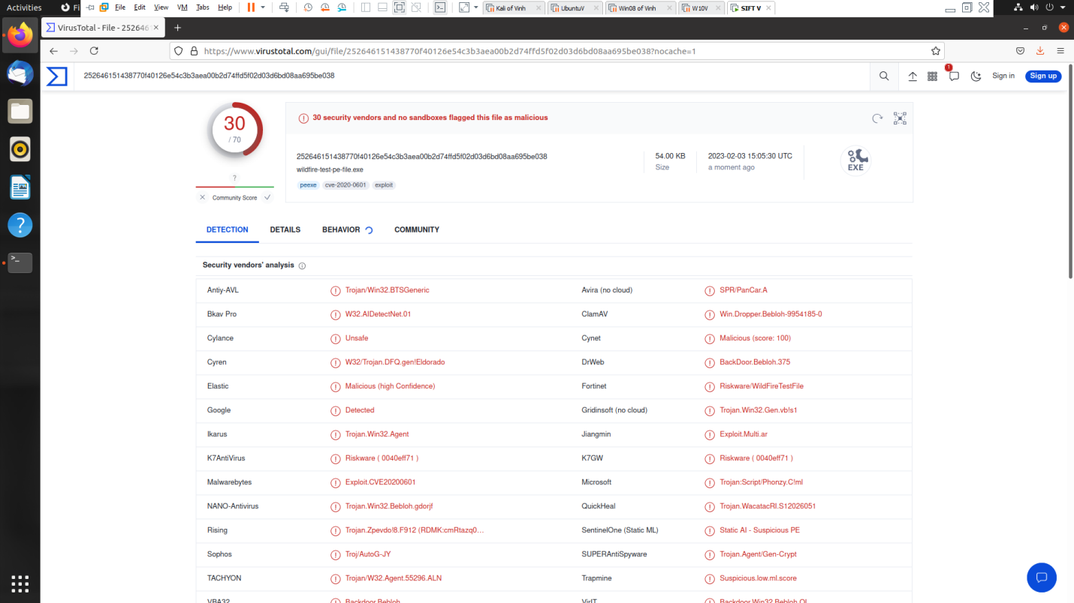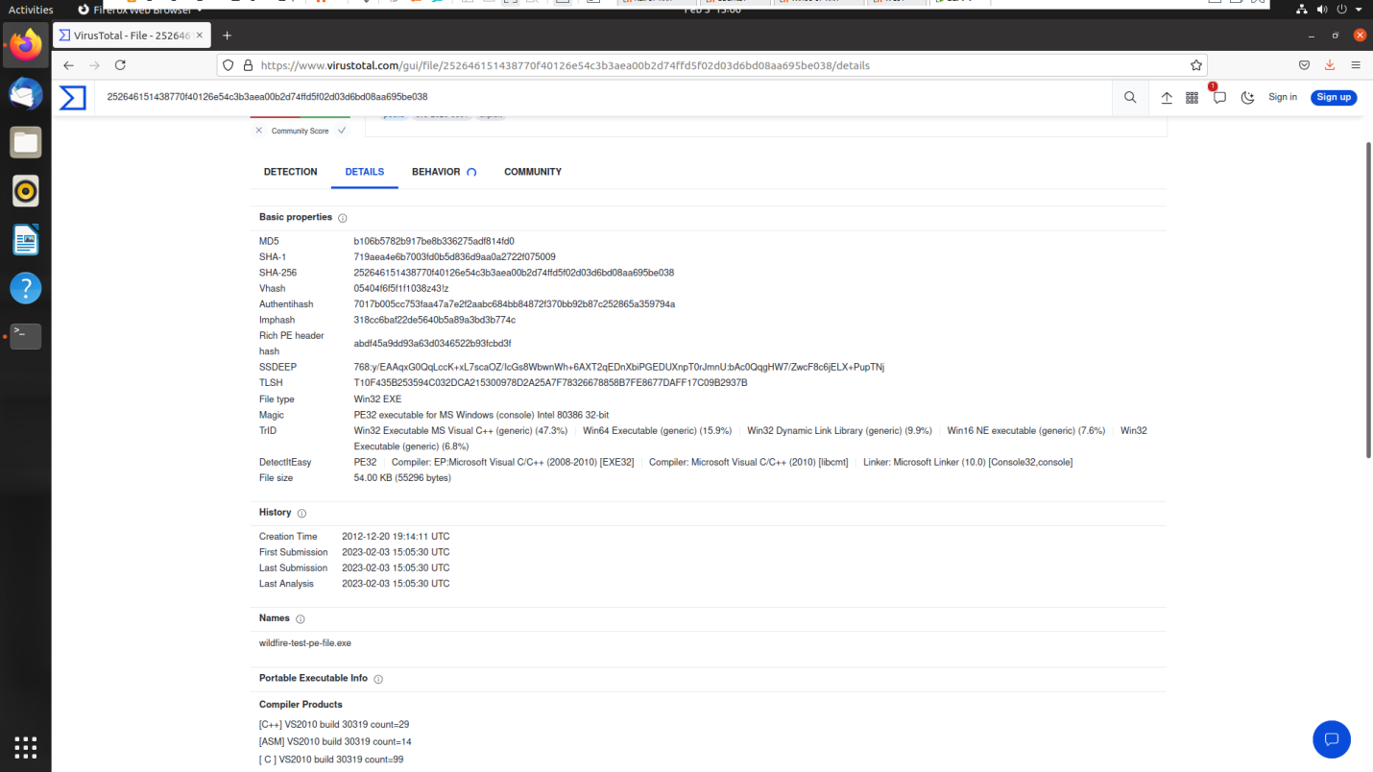

Upload Jotti
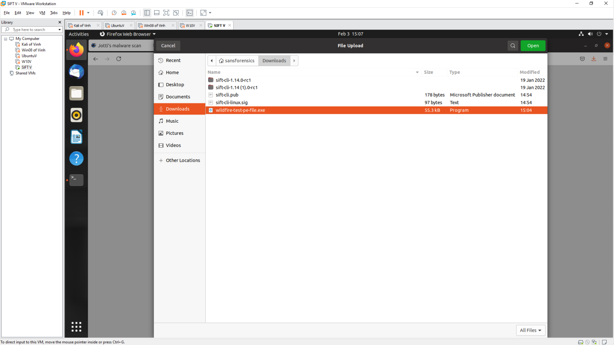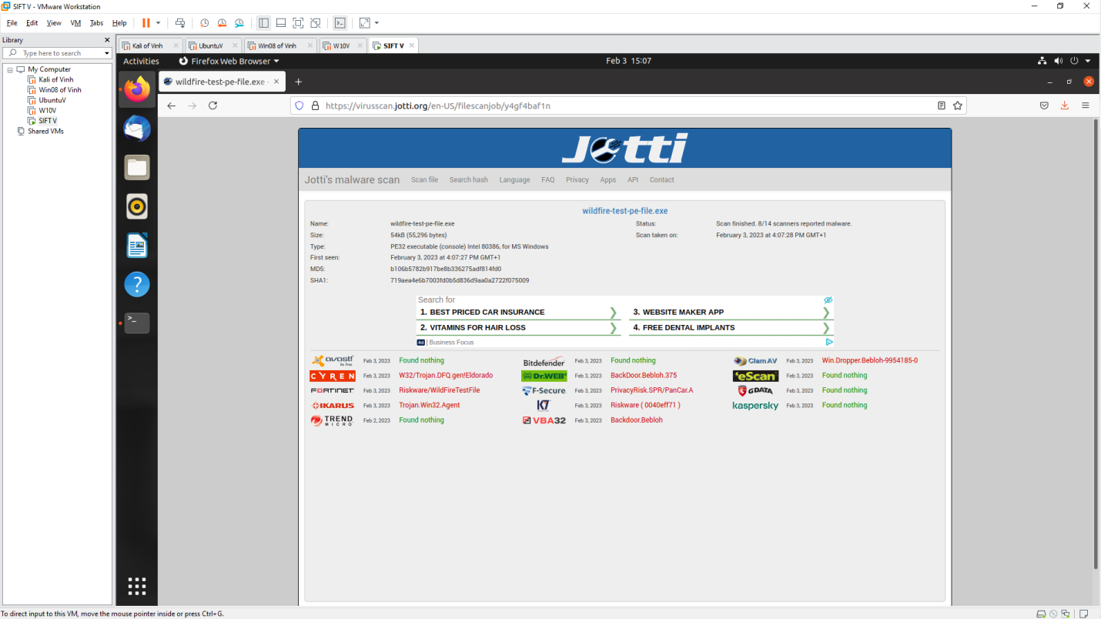

MetaDefender
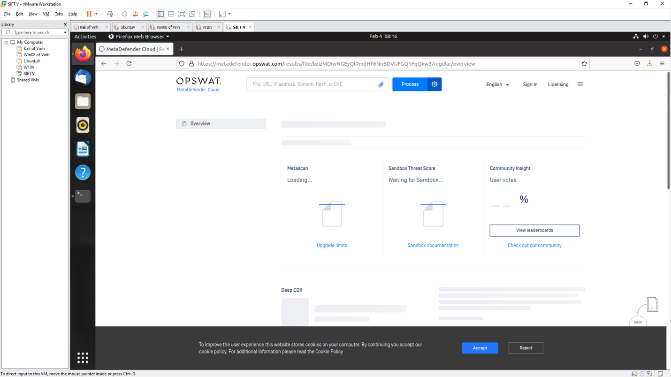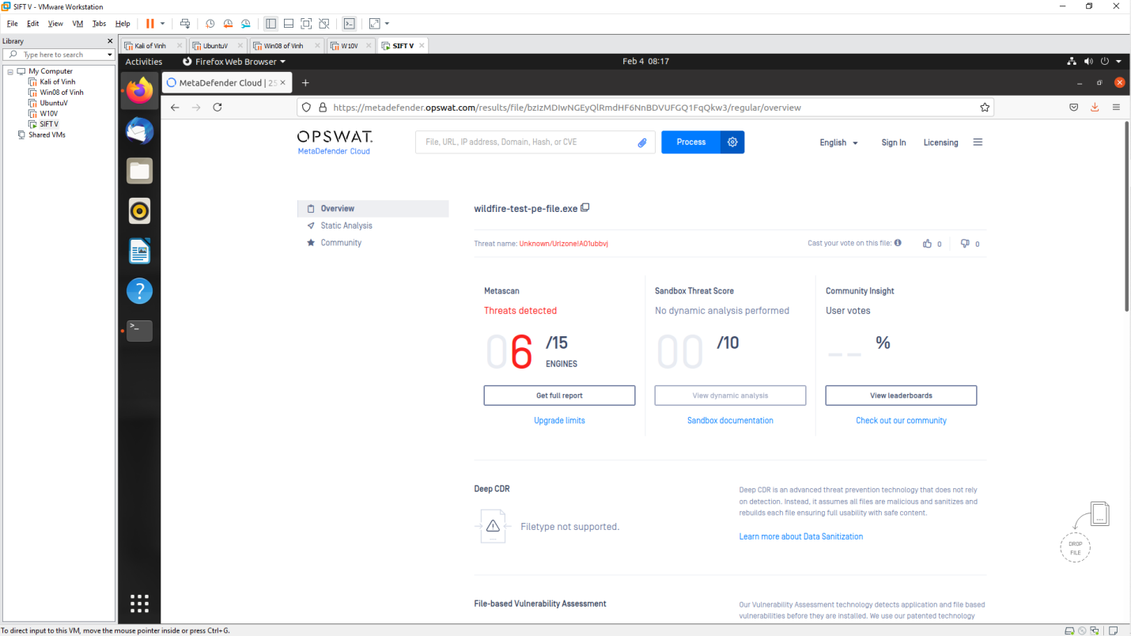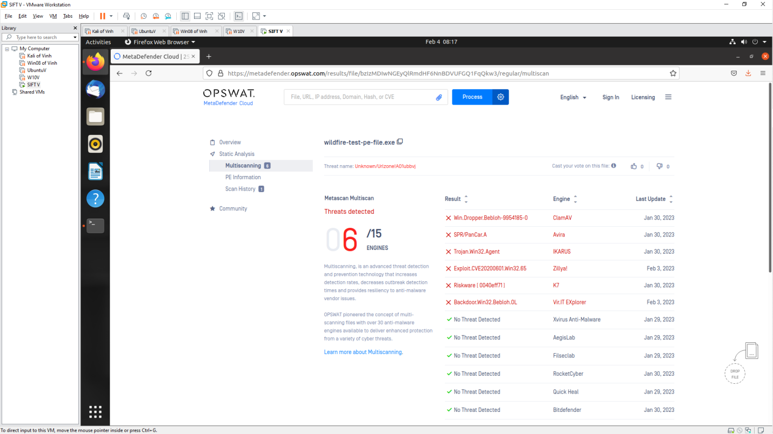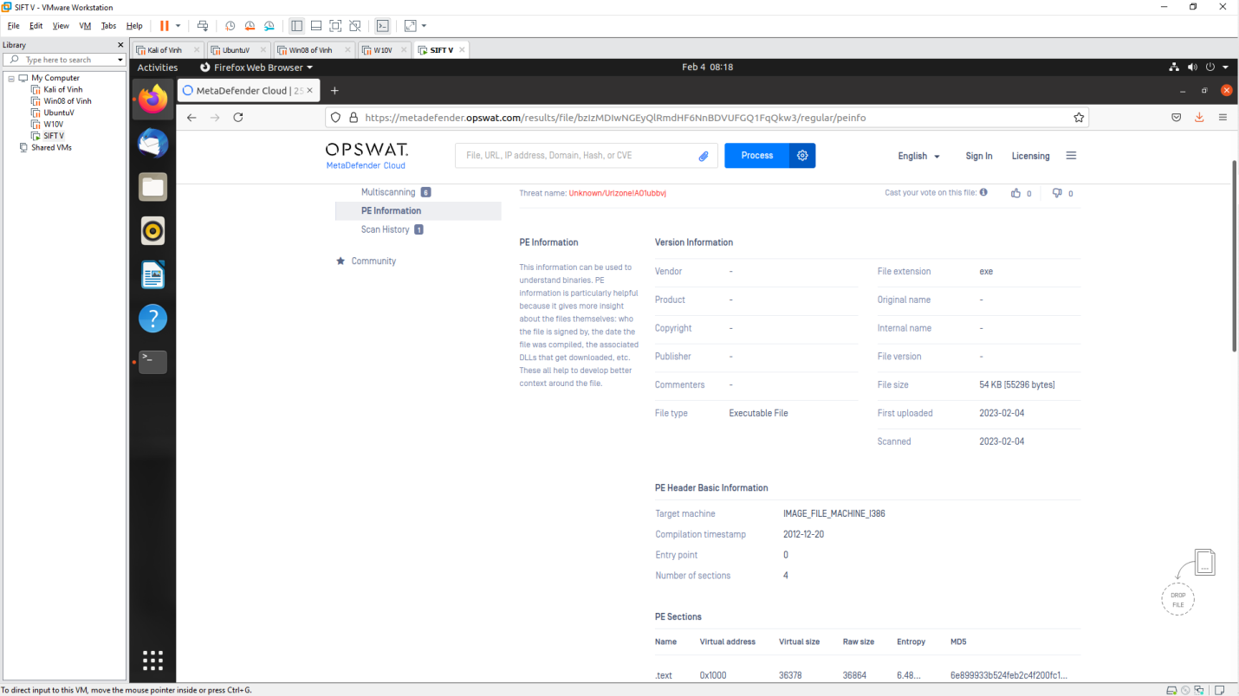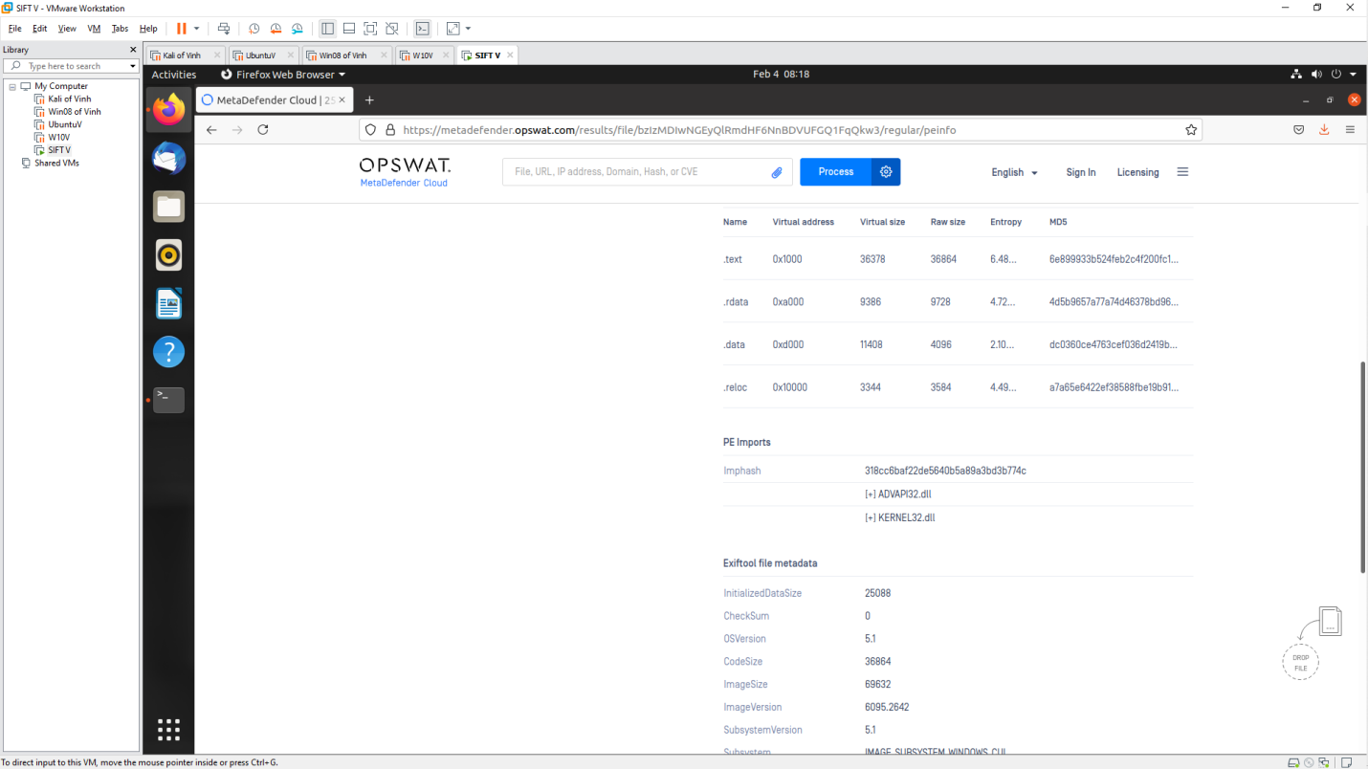

Conclusion
- Virustotal is the website used to scan Malware most effectively when it gives the most results, history of malware. Meanwhile, Jotti gives more results than MetaDefender but the specific information of MetaDefender is clearer than Jotti

Use tools on SIFT Workstation
